# Sheet 4A Pizza Ordering Application

Create a C# Application similar to this:

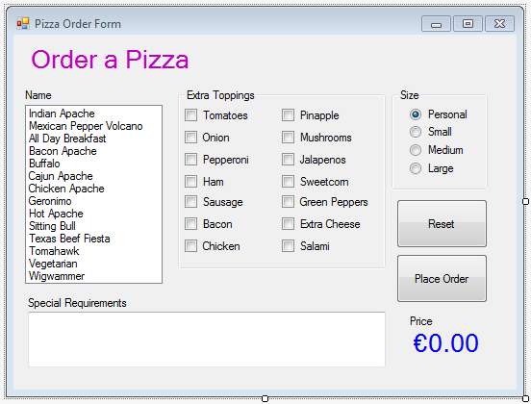

NOTE:

The Control with the Pizza names is a Listbox and the Control for the Special Requirements is a Textbox with its Multiline property set to true.

When the user chooses a pizza name, extra toppings or a size you should update the price accordingly. When the Place Order button is pressed, you can summarise their choices in a message box and include any ‘special requirements’ entered into the multiline textbox.

This application will be used in further exercises.